Web-based Complaint management system
Chapter one : Introduction
1.0 introduction
Students are the main stakeholders in educational institutions, and the success of the academic environment as a whole greatly depends on how satisfied they are. However, students frequently encounter a variety of difficulties that can impede their learning process, from academic and administrative worries to facility-related obstacles. Educational institutions must handle student complaints in a methodical and open manner in order to properly address these issues. To make sure that students feel heard and supported, a complaint management system (CMS) created especially for them can be an effective tool for streamlining the reporting, monitoring, and addressing of complaints. Complaint Management system may be a platform independent application, so this web application are often accessed anywhere within the system. this is often also developed for reduces the communication cost between the staffs and to supply the efficient service to their staffs. The main objective of this Complaint Management system is to specialize in the problems associated with internal system.
1.1 background of the system
In globally, A complaint is a disclosure of dissatisfaction by an individual or organization to a particular institution or unit related to the results of the provided products or services [1]. The submitted complaint is expected to be responded to by the relevant institution or unit. Complaints can be a very important source of information to measure the performance of an institution,The complaint allows the institution to fix problems in its performance immediately. That way, the institution can improve the efficiency of its performance and service quality [2]. Good service quality from an institution or unit can provide opportunities to turn dissatisfied customers into satisfied customers and can even become regular customers[3]. Complaint management encompasses a systematic approach to handling, managing, responding to, and reporting customer grievances. It necessitates a well-structured framework and continuous monitoring to expedite resolutions promptly. CMS presents itself as a step-by-step methodology for receiving, recording, processing, responding to, and reporting on complaints [4].
In Africa, a complaint is a statement in which you express your dissatisfaction with a particular situation [5]. Although a lot of systems that were manual in the past have gone digital, but the issue of complaint management still remains manual. Many students, especially fresher, have many issues, which they are dissatisfied with, but they keep these issues bottled down
Complaints are challenging to track and monitor, and manually managing each one would be inefficient and time-consuming.The current process of filing complaints has proven to be highly stressful for students and staff, especially in universities in developing nations since it necessitates repeated journeys to the proper departments to guarantee that problems are processed [6].
In Somalia, The effectiveness of student complaint management
helps ensure a comfortable atmosphere to the university users,
motivates learners, and upholds the reputation of the organization. Traditionally, universities have employed manual systems such as suggesting boxes and in person complaint submission to cater to student issues [7].
Today, complaint management systems leverage web-based platforms and mobile apps. These systems offer real-time tracking, automated responses, and predictive insights, making the process more efficient and user-friendly. The transition to web-based systems has been driven by several factors, including the growing demand for transparency, efficiency, and accessibility in handling student complaints.
The online development of web-based students complaint management system this system is Proposed to help the faculties at Salaam University automate the tasks associated with the management of the complaints project.
1.2 problem statement
The information about complaints and issues is currently recorded in spreadsheets. Due to several challenges, this data may be lost or mismanaged by the university. To address this problem, the faculties at Salaam University have identified the need for a computerized complaint management system to efficiently handle and track student and staff complaints. In this work, the complaint management process was analyzed in detail, and the following issues were identified: time-consuming manual tracking of complaints, lack of centralized storage and backup, and poor search and retrieval capabilities. A web-based complaint management system could help salaam university staff efficiently manage and resolve complaints. The system would ensure that complaints are properly logged, tracked, and resolved in a timely manner, avoiding duplication or loss of information. Additionally, it would provide a centralized platform for storing and retrieving complaint records, improving transparency and accountability. The system could also serve as a reference for future improvements, allowing the university to identify recurring issues and implement proactive measures to address them.

1.2.1 Providing Solution For The Problem
The problem statement that we came back to solve is what we did in this project to address the needs of the students.
1.3 purpose of project
Complaint Management System provides an online way of solving the problems faced by the salaam university students. the main purpose or the aim of this project is saving time and reducing corruption , And The ability of providing many of the reports on the system , and add to improve the process of submitting a complaint.

1.4 Project objectives
The objectives of this study are the goals we hope to achieve when the new system is up and working.
The objectives are:
1) To plan easy complaint management system dfor students to apply the complaint
2) To analyze the complaint made by students
2) To implement a tertiary institution web-based student complaint management system that allows students to lay their complaints and receive rapid feedback in a much easier manner than the existing system

1.5 Project scope
This study covers the procedure for managing complaints in salaam university. The type of complaints that would be managed with this system is missing lecture , lack infrastructure for effective learning
1.6 Significance of the objectives
The significance of this system is to serve better than the existing system which is highly manual and therefore difficult in terms of monitoring the complaint in the University, improve database and enhance effectiveness, efficiency and security of the system. The system is expected to be easy as user can browse their complaint anytime Generally this system provides the following significances to the system users
- To make the compliance process to be easy
- Any student can send his/her complaint from anywhere and anytime using his smart phone.
- Reduce the paper work
- To reduce the unwanted communication from customers
- Customers use time effectively.
- To students satisfaction.
- Faster decision making due to the report generation functionality.
- Creates Job satisfaction to the employees.

1.7 Report organization

In this research, chapters organized as follows:
Chapter One: is an introduction and background of web-based ance evaluacomplain management system. Furthermore, this chapter will cover the objectives, scope as well as significance of the study and how the project was organized.
Chapter Two: This chapter also discusses the introduction of relevant literature of design and implementation of an complaint management system with listing concepts and opinions from experts or authors. This chapter deals with previous work or existing systems
Chapter Three: Defines how the data collected, analyzed, how the interview has been done and the finding of the analyzed data and also the chapter will discuss how the system was analyzed using UML (use case diagram).
Chapter Four: Proposes the design and implementation of an complaint management system in details
Chapter Five: is the last chapter of the project and it describes the implementation of this project and testing it to produce a complete functioning system.
Chapter Six: Finally, this chapter provides conclusion and recommendations by describing the strengths and achievements of the projects. This chapter also gives the weaknesses of the design and implementation of an complaint management system.
Chapter two

LITERATURE REVIEW

2.1 Introduction
Universities and schools continue to make incremental steps into the digital era, For higher education institutions, it’s critical that they must be able to arrange their information storage for easier, more effective access.
A complaint management system (CMS) is a crucial component in any organization, particularly in academic institutions where students require an efficient platform to express their concerns. A web-based complaint management system (WCMS) facilitates real-time complaint submission, tracking, and resolution. This chapter reviews relevant literature on CMS, covering theoretical and conceptual frameworks, case studies, comparisons with existing systems, and a summary of key findings.

2.2 Theoretical and Conceptual Development
In traditional complaint management systems, the process of handling and resolving complaints is typically carried out through manual or paper-based methods. In the traditional approach, complainants typically submit their complaints through physical complaint forms, suggestion boxes, email, or direct communication with relevant personnel.
manual submission process may involve filling out paper forms or sending written correspondence (Devaraj, S., & Kohli, R. 2003). Upon receiving a complaint, the traditional approach involves documenting the details manually on paper. Complaints may be logged into physical registers or filed in paper folders. This method can be time-consuming and prone to errors in information management (Parasuraman, A., Zeithaml, V.A., & Berry, L. L. 1985). In a traditional system, complaints are manually routed to the relevant personnel or departments responsible for addressing the specific issue raised in the complaint. This process often relies on manual coordination, which can introduce delays and potential miscommunication (Bitner, M. J., Booms, B. H., & Tetreault, M. S. 1990). Complaints are manually tracked using spreadsheets, logbooks, or other physical records. This method requires diligent record-keeping and manual updates to track the status of complaints.
Follow-up actions and resolution progress are communicated through direct interaction or traditional communication channels (Johnston, R., & Clark, G. 2005).
Complaint management ensures that all reported complaints in an organization are adequately followed up and that any issues are immediately resolved. Complaints are challenging to track and monitor, and manually managing each one would be inefficient and time-consuming.The complaint management system recognizes the link between the goal of resolving complaints and customer loyalty, and it make a generous effort to act quickly on issues that can be fixed right away[9].
A complaint is defined herein as an issue arising when an incident occurs, and there is an absence of willingness or initiative to address the matter at hand. Failure to articulate concerns when something goes awry not only deprives students of a platform for expression but also hinders the institution's potential for improvement.

2.3 Case Study of the Research
Salaam University (SU) is one of the most popular Private University which is non-profit academic institution in Somalia. The credit for the idea of establishing this university goes to Somali Scholars felt the need for a university under private initiative, and discussed the concept of establishing this university with a group of intellectuals, researchers and educationists, at home and abroad. By the Grace of Allah, Salaam University (SU) was founded in the year 2009.
Vision
SU aspires to be university of choice in nurturing innovation and talent in science, technology and development
Mission
SU mission is to preserve, create, and disseminate knowledge, conserve and develop scientific, technological and cultural heritage through quality teaching and research.

2.4 Comparison Between Existing Systems
With that on different institutions employ various CMS solutions. A comparative analysis of existing systems highlights their strengths and weaknesses.
This is some comparison on existing systems and ower one
Feature | Traditional CMS | Web-Based CMS
Accessibility | Limited (Office-based) | 24/7 Online Access
Response Time | Slow (Manual Processing) | Fast (Automated Processing)
Transparency | Low | High (Real-time Tracking)
User-Friendliness | Moderate | High (User-centered Design)
Cost | High (Paper-based & Staff-intensive) | Low (Digital & Automated)
From the comparison, it is evident that a web-based CMS provides significant improvements in accessibility, transparency, and efficiency.

2.5 Chapter Summary
This chapter explored the theoretical and conceptual foundations of WCMS, reviewed case studies demonstrating successful implementations, and compared existing systems. The findings indicate that web-based complaint management systems significantly enhance efficiency, accessibility, and user satisfaction. The next chapter will discuss the research methodology adopted for developing the WCMS for university students.

CHAPTER THREE
SOFTWARE PLANNING AND ANALYZING

3.0 Introduction

Software planning: Planning is an objective of each and every activity, where we want to discover things that belong to the project. An important task in creating a software program is extracting the requirements or requirements analysis. Customers typically have an abstract idea of what they want as an end result but do not know what software should do. Skilled and experienced software engineers recognize incomplete, ambiguous, or even contradictory requirements at this point. Frequently demonstrating live code may help reduce the risk that the requirements are incorrect. Once the general requirements are gathered from the client, an analysis of the scope of the development should be determined and clearly stated. This is often called a scope document. (Ralph & Wand, 2009)
Software analyzing: In computer science, program analysis is the process of automatically analyzing the behavior of computer programs regarding a property such as correctness, robustness, safety and liveness. Program analysis focuses on two major areas: program optimization and program correctness. The first focuses on improving the program’s performance while reducing the resource usage while the latter focuses on ensuring that the program does what it is supposed to do. Program analysis can be performed without executing the program (static program analysis), during runtime (dynamic program analysis) or in a combination of both. (Agrawal & Horgan, 2020)
This chapter will include the following sections: Introduction, Operational Framework, Work Break down structure (WBS), System Requirement, Problem Analysis Identification, Requirements Gathering Techniques, Process Modeling, Data Modeling, Suitable solution Strategies of the proposed system, System Feasibility and Chapter Summary.

3.1 Operational Framework
The Operational Framework starts planning, proposal, chapter one introduction, chapter two literature review, chapter three software planning & analyzing chapter four software design, chapter five system implementation and finally chapter six conclusions & enhancement

Interview
Data Collection
Literrature Review
Observation
Data Analyze
Design Prototype
Develop
Prototype
Yes
initiation and
Planning
Test
No

Figure 3.
1

Operational Framework

3.2 Work Break down structure (WBS)
Work break down structure (WBS) is a vehicle for breaking an engineering project down into subproject, tasks, subtasks, work packages, and so on. It is an important planning tool which links objectives with resources and activities in a logical framework. It becomes an important status monitor during the actual implementation as the completions of subtasks are measured against the project plan. (Tausworthe, 1984)

Specification
Development
Implementation
Validation
Figure 3. 2 Work Break down Structure (WBS) Process

3.3 System Requirement
System requirement is a characteristic or feature that must be include in any information system to satisfy users. Since the Administrator and the users are the main target collection of our software, I will only concern about some important functions for the admin and the user. the system needs Applications like web browsers safari, Mozilla Firefox, Google chrome and internet connection. they include the following interfaces:
- User Interfaces: The keyboard, mouse, menus of a computer system. The user interface allows the user to communicate with the operating system.
- Software Interfaces: The languages and codes that the applications use to communicate with each other and with the hardware.
- Hardware Interfaces: The wires, plugs and sockets that hardware devices use to communicate with each other, computer systems, or any other medium of communication. A physical interface is the interconnection between two items of hardware or machinery.

3.4 Software Requirement Specification
One of the critical success factors in the development of high-quality software product or website is the deep understanding of the user’s real requirement as opposite to their perceived requirements. This will make the product very easy to develop, maintain, and to use the software properly by the end users.
User requirement is the process by which user desires, needs, and expectations are gathered in order to establish what the users will actually use the software for, and recorded in a way that will be meaningful both to the users and developments.
Software Requirements
Table 3. 1 Software Requirements
Operating System | : | Macintosh, Linux, Windows Xp,7,8,8.1,10,11
Front End | : | PHP , HTML, CSS, JAVASCRIPT
Back End | : | MySQL

Hardware Requirement
Table 3. 2 Hardware Requirements
1 Computer HP/Dell/Lenovo
2 Corei5 or Corei7
3 4GB or 8GB RAM
4 500 or 1 TB Hard Disk or 500 GB Solid State Drive (SSD)

3.5 User Requirements Definition
A document that defines what a proposed system must be capable of doing to solve the problems of a defined set of potential users of such a system. The user requirements specification should be completely independent of any solution-oriented bias and must use terminology from the problem domain of the users. It must be understandable by the intended users who must “buy in” to it. Therefore, it is most unlikely to be created using a conventional requirements-analysis method, since these introduce solution bias, representations, and concepts that are rarely understood by (and are irrelevant to) the users (user-requirements, 2017).
3.6 Problem Analysis Identification
Problem analysis is focused on identifying cause and effect. It can be very difficult to determine what is cause and what is effect. For example, a problem that initially looks like a human error may be a latent human error that is the result of a poorly designed user interface, system or process.
3.7 Requirements Gathering Techniques
Requirements gathering techniques are a process of collecting data from different sources. Data or (datum in singular) is valuable pieces of information collected during the research. Data can be divided in to two categories: primary data and secondary data. In this research, the primary data comes from observation to the respondents. First, the observation will be carefully evaluated and to ensure its validity and reliability by pilot test. There are various methodologies for gathering data as the following:
- Interviews
- Observations

3.7.1 Interview
An interview is a formal face-to-face meeting, especially, one arranged for the assessment of the qualifications of an applicant, as for employment or admission. A conversation, as one conducted by a reporter, in which facts or statements are elicited from another, the interview is the primary technique for information gathering during the systems analysis phases of a development project. It is a skill which must be mastered by every analyst. The interviewing skills of the analyst determine what information is gathered, and the quality and depth of that information.
Interviewing, observation, and research are the primary tools of the analyst.
The interview is a specific form of meeting or conference, and is usually limited to two persons, the interviewer and the interviewee. In special situations there may be more than one interviewer or more than one interviewee in attendance(martymodel, 2017).
Advantages of interview
The main advantage of interviews is that the researcher (interviewer) can adapt the questions as necessary, clarify doubt and ensure that the responses are properly understood, by repeating or rephrasing the questions. The researcher/interviewer can also pick up nonverbal cues from the respondent. Any discomfort, stress and problems that the respondent experiences can be detected through frowns, nervous taping and other body language, unconsciously exhibited by any person. This would be impossible to detect in a telephone interview. So face-to-face helps the interviewee to get the desired results and help them the expression of the person to whom they are interviewing. By reading the facial expression of the respondent the interviewer can easily understand what the respondent wants to tell them about anything (answers-yahoo, 2017)
Disadvantages of interview
The main disadvantages of face-to-face interviews are the geographically limitations they may impose on the surveys and the vast resources needed if such surveys need to be done nationally or internationally. The costs of training interviewers to minimize interviewer's biases for example differences in questioning methods, interpretation of response are also high. Another drawback is that respondents might feel uneasy about the anonymity of their responses when they interact face to face interviews.
3.7.2 Observation
An observation is a data collection method used to gather detailed information about a situation or event. Observation data is used to describe the setting, activities, participants, and the meaning of the observations from the observer's perspective. Observation in this project will be based on facts which are both accurate and detailed, but left any irrelevant or slight information that makes the description difficult to understand. This data allows the reader to fully understand the situation.
Advantages of observation
- Allows you to directly see what people do practically rather than relying on what people say they did.
- Observer’s document program activity takes time and cost gathering providing documentation, rather than relying on recollections of the events.
Disadvantages of observations
- Observer bias may occur. (Observer may only notice what interests him or her).
- With participant’s observation, a skilled facilitator is needed to help participants present a critical evaluation.
3.8 Process Modeling
A process model is a formal way of representing how a computer system operates. It illustrates the processes or activities that are per-formed and how data move among them. A process model can be used to document the current system (i.e. as-is system) or the new system being developed (i.e. to-be system). Whether computerized. Process modeling is the process and analysis of data and objects that are used in business or other context and identification of the relationship among these data objects. Data modeling is a first step in doing object-oriented Programming and involves professional data modelers working closely with business stakeholders, as well as potential users of information system.
3.8.1 Data flow Diagram (DFD)
Data Flow Diagrams show information transfers and process steps of a system. The general concept is an approach of a depicting how occurs input in a system, further processes and what runs out. The aim of DFD is in accomplishing of understanding between developers and users. Data flow diagrams are maintained with other methods of structured systems analysis.
A data flow diagram (DFD) illustrates how data is processed by a system in terms of inputs and outputs. As its name indicates its focus is on the flow of information, where data comes from, where it goes and how it gets stored.
- Graphical representation of the "flow" of data through an information system;
- Modeling process aspects;
- An overview of the system;
- For the visualization of data processing (structured design);
- What kinds of information will be input to and output from the system;
- Where the data will come from and go to;
- Where the data will be stored.(conceptdraw, 2017).

Data Flow Diagrams notations:
The Data Flow Diagrams solution from the Software Development area of ConceptDraw Solution Park provides three vector stencils libraries for drawing DFD using the ConceptDraw PRO diagramming and vector drawing software.
The design elements library DFD, Yourdon and Coad notation contains 22 data flow diagram symbols of Yourdon/DeMarco DFD notation(conceptdraw, 2017)
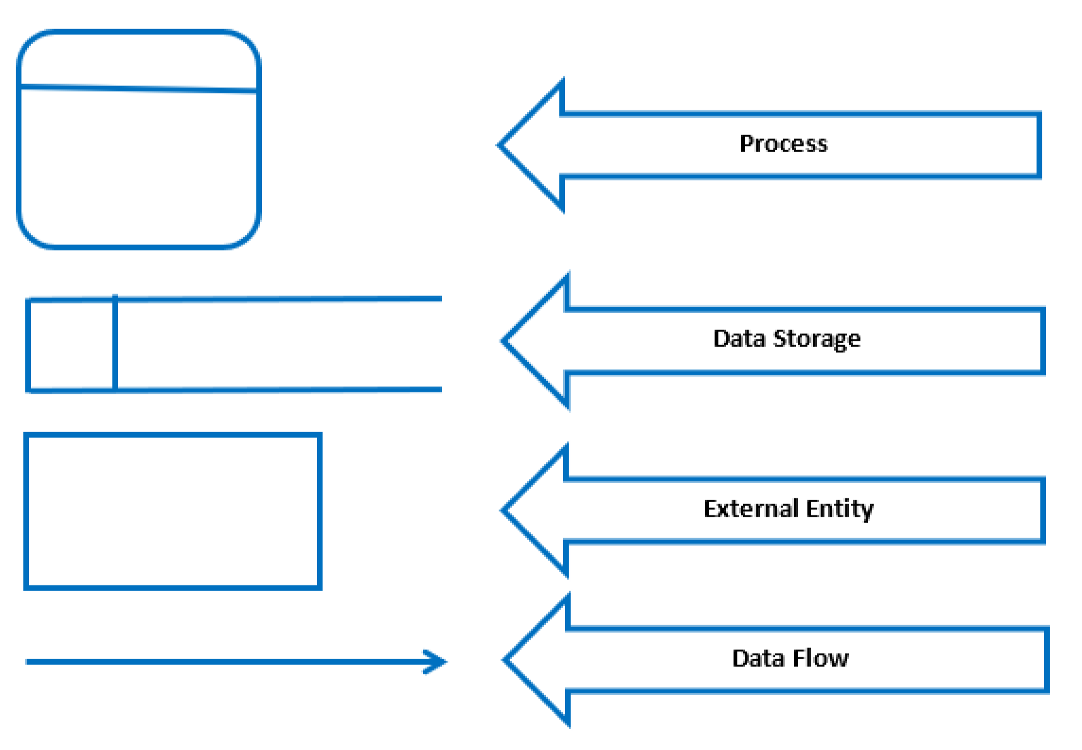

Figure 3. 3 UCD

3.8.2 Unified Modeling Language (UML)
UML stands for Unified Modeling Language; UML is a way of visualizing a software program using a collection of diagrams. The notation has evolved from the work of Grady Booch, James Rumbaugh, Ivar Jacobson, and the Rational Software Corporation to be used for object-oriented design, but it has since been extended to cover a wider variety of software engineering projects.
Today, UML is accepted by the Object Management Group (OMG) as the standard for modeling software development(smartdraw, 2017)
Types of UML Diagrams
The current UML standards call for 13 different types of diagrams: class, activity, object, use case, sequence, package, state, component, communication, composite structure, interaction overview, timing, and deployment.
3.8.2.1 Use Case Diagram (UCD)
A use case is a methodology used in system analysis to identify, clarify, and organize system requirements. The use case is made up of a set of possible sequences of interactions between systems and users in a particular environment and related to a particular goal. It consists of a group of elements (for example, classes and interfaces) that can be used together in a way that will have an effect larger than the sum of the separate elements combined(techtarget, 2017).

Here are the symbols of UCD:-
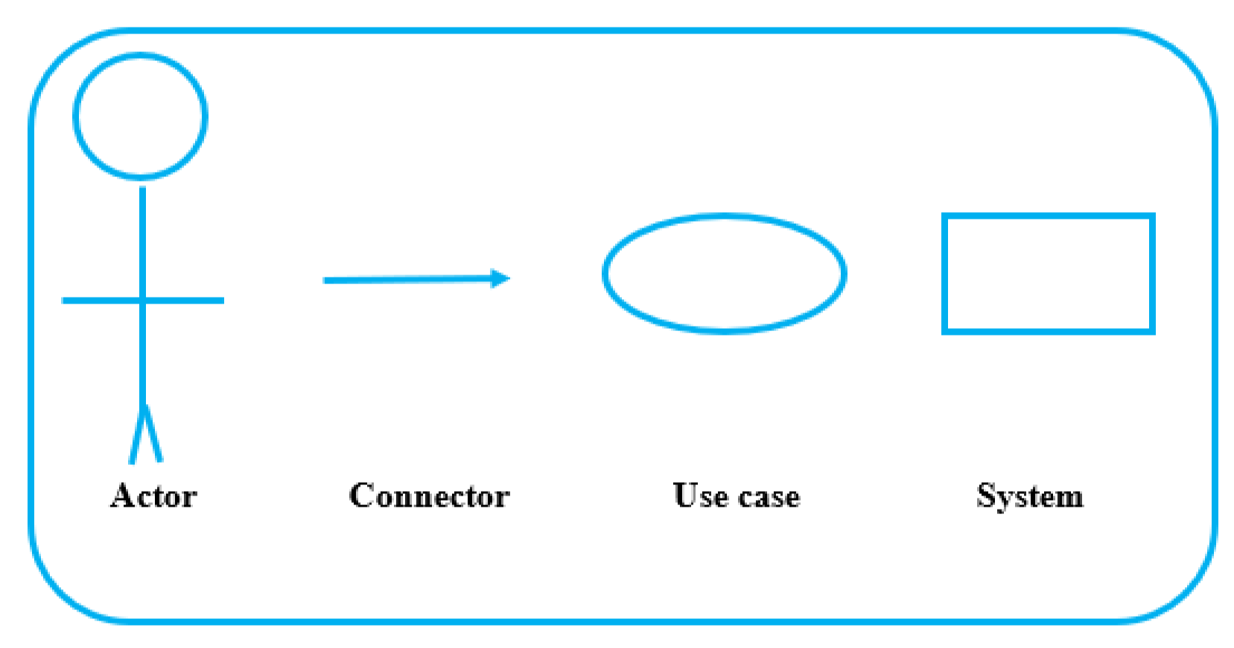
Figure 3. 4 UCD



Figure 3. 5 Use Case Diagram

Admin login

Manage complaint

Student registration

Edit Personal info

Student login

Manage students

Make complaint

Users

Admin

Logout
3.9 Data Modeling
Data modeling is the analysis of data objects and their relationships to other data objects. Data modeling is often the first step in database design and object-oriented programming as the designers first create a conceptual model of how data items relate to each other. Data modeling involves a progression from conceptual model to logical model to physical schema(webo, 2017).
Data modeling is the process and analysis of data and objects that are used in business or other context and identification of the relationship among these data objects. Data modeling is a first step in doing object-oriented programming and involves professional data modelers working closely with business stakeholders, as well as potential users of information system.
3.9.1 Entity Relationship Diagram
An entity-relationship (ER) diagram is a specialized graphic that illustrates the interrelationships between entities in a database. ERD show entities in a database and relationships between tables within that database. It is essential to have one of these if you want to create a good database design. The patterns help focus on how the database actually works with all of the interactions and data flows, although another useful tool is a Data Flow Diagram (DFD) which more directly described ERD is a detailed, logical representation of the entities, associations and data elements for an organization or business. ERD is a graphical modeling tool to standardize ER modeling; the modeling can be carried out with the help of pictorial representation of entities, attributes and relationships(lucidchart, 2107).
The basic building blocks of ERD are Entity, Attributes, Relationship and lines entity is an object that exists and is distinguishable from other object in other words Entity types or Entity set is a collection of similar entities; an entity may belong to more than one entity type. A relationship is an association of entities where the association includes one entity from other particular types is meaningful association before entity types. Attributes are properties of entity types in other words; entities are described in a data base by a set of attributes (Peter Pin-Shan Chen, 1976)
3.9.1.1 ERD SYMBOLS
The ERD is used to represent database schema, here are some symbols used to represent ERD Symbols:
A rectangle represents an Entity, An Ellipse represents an attribute, A diamond represents a relationship Lines represent linking of attributes to entity sets & of entity sets to relationship sets.


Figure 3.
6

ERD

Entity

Relationship

Attribute

Line

3.9.1.2 TYPES OF RELATIONSHIP
Relationship is an association among one or more entities. This relationship can be broadly classified into one-to-one relation, one-to-many relation, many-to-many relation.
- One to many Relationship Type: Abbreviated 1:M, the relationship that associate one entity to more than one entity is called one to many relationships: - Example is country having states for one country there can be more than one states hence is an example one to many relationships.
- One to one Relationship Type: Abbreviated 1:1, one to one relationship is a special case of one to many relationships. True one to one relationship is rare. The relationship between the president and Country is an example is one to one relationship.
- Many to Many Relationship Type: Abbreviated M: M, the relationship between EMPLOYEE entity and PROJECT entity is an example of many to many relationships. Many employees will be working in many projects hence the relationship between employee and project is many to many relationships.
- Many to One Relationship Type: Abbreviated M: 1, the relationship between EMPLOYEE and DEPARTMENT is an example of many to one relationship, there may be EMPLOYEE working in one DEPARTMENT. Hence relationship between EMPLOYEE and DEPARTMENT is many to one relationship (Aplim, 2010).

Table 3. 3 ERD Proposed System

Relation Type Representation
One-to-one
One-to-many
Many-to-many
Many-to-one
3.9.1.3 ERD of the Proposed System

Online Photographer Booking
Management System
Customer
Payment
Admin
Customer
Photographer
register
create
Users
book
get

Figure 3. 7 ERD of the system

3.10 Suitable Solution Strategies of the Proposed System
As we are reaching the development phase, this section would contemplate on other ways project’s objectives can be achieved. As you may know, the system will be developed in . programming language and it is the most used or popular.

3.11 System Feasibility
A feasibility study for an information system project is an in-depth look at the project in order to determine whether or not an organization should proceed with its implementation. Feasibility studies provide project managers with an overview of the primary issues related to the project, as well as insights about the outcomes of the project, before the company invests too much time and money(reference, 2017).
A feasibility study could be used to test a new working system, which could be used because the Feasibility study is an analysis of possible alternative solutions to a problem and a recommendation on the best alternative. It can decide whether a process be carried out by a new system more efficiently than the existing one.
Feasibility study is divided into four types: -
- Technical Feasibility.
- Operational Feasibility.
- Economic Feasibility.
- Schedule Feasibility.

3.11.1 Technical Feasibility
Technical Feasibility is defining as the feasibility that is concerned with specifying equipment and software that will successfully satisfy the requirement. It compasses the technical needs of the system Configuration of the system is given a huge importance than the actual make of hardware while examining technical feasibility(quora, 2017).
This can be counted in terms of volumes of data, trends, frequency of updating, etc. in order to estimate whether the new system will perform sufficiently or not. Technological feasibility is carried out to determine whether the company has the capability, in terms of software, hardware, personal and expertise, to handle the completion of the project.

Table 3. 4 Technical Feasibility
No Item Description | Quantity | Cost Per Unit | Amount
1. Desktop Core i7 | 1 | $530.00 | $530.00
2. Epson LaserJet | 1 | $160.00 | $160.00
Total |  |  | $690.00

Table 3. 5 Items

No Item Description | Quantity | Cost Per Unit | Amount
1. PHP and MYSQL | 1 | Free
Total |  |  | Free

3.11.2 Operational Feasibility
Operational feasibility is the ability to utilize, support and perform the necessary tasks of a system or program. It includes everyone who creates, operates or uses the system. To be operationally feasible, the system must fulfill a need required by the business. The following table will show the training cost of the user of the system.
Table 3. 6 Operational Feasibility
Activities | Duration | Expected Cost
Training Current  Employee | 1 Week | $350.00
Training New Employee | 2 Week | $250.00
Total |  | $600.00

3.11.3 Economic Feasibility
Economic analysis is the most frequently used evaluating the effectiveness of proposed system, more commonly known as benefit analysis.
The benefit analysis is to determine benefits and saving which are expected from candidate system and compare them with cost. If the benefits are more than the cost, the decision is made to design and implement the system. The cost and benefits may be direct or indirect and tangible or intangible.

Table 3. 7 Economic Feasibility
Types of feasibility | Description | Expect Cost
Technical feasibility | Hardware & software | $690.00
Operational feasibility | Training with best option | $600.00
Total |  | $1290.00

3.11.4 Schedule Feasibility
Typically, this means estimating how long the system will take to develop, and if it can recomplete in a given time period using some methods like payback period. Schedule feasibility is a measure of how reasonable the project timetable is.
This involves questions such as how much time is available to build the new system, when it can be built, whether it interferes with normal business operation, number of resources required, dependencies, can the system be developed in time etc. The project duration schedule is explained in the following.

Table 3. 8 Schedule Feasibility

Level | Phase Name | Duration
1 | Analysis phase | 4 weeks
2 | Design phase | 2 weeks
3 | Coding | 6 weeks
4 | Implementation and Testing | 2 weeks
5 | Operation and maintenance phase | 2 week
Total |  | 16 weeks

3.12 Chapter Summary
This chapter presented the following sections: Introduction, Operational Framework, Work Break down structure (WBS), System Requirement, Problem Analysis Identification, Requirements Gathering Techniques, Process Modeling, Data Modeling, Suitable solution Strategies of the proposed system, System Feasibility and Chapter Summary.

